**NAAN MUDHAVAN**

**ASSIGNMENT DOCUMENT**

**COURSE TITLE** : DIGITAL MARKETING

**COLLEGE CODE** : 1105

**COLLEGE NAME** : GOJAN SCHOOL OF BUSINESS AND TECHNOLOGY

**NM ID** : FBA06EE4A1B0828A00F4BB1F904486C5

**NAME** : RAJKUMAR R

**REGISTER NUMBER** : 110520106330

**YEAR** : 4TH YEAR

**DEPARTMENT** : ELECTRONICS AND COMMUNICATION ENGINEERING

1. Create a blog or website using Blogspot and Wordpress. Customize the theme design and post new article with 500 words.

Link: <https://summerfashion001.blogspot.com/2023/10/richard-mille.html>

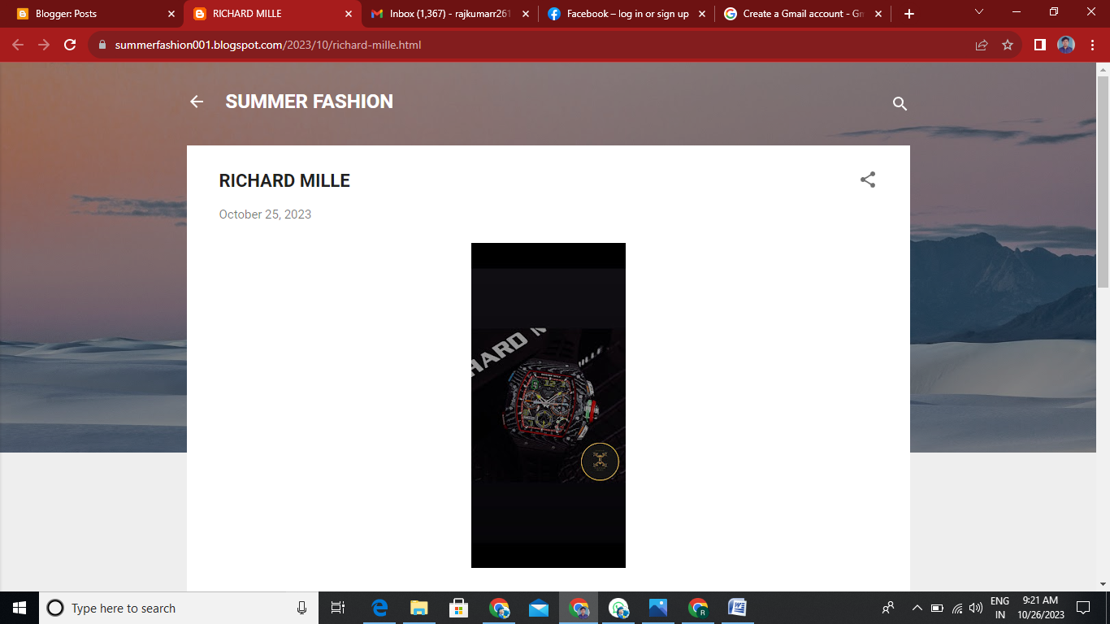

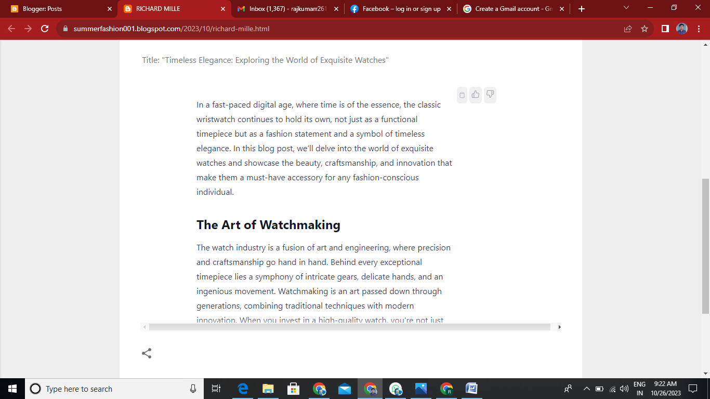

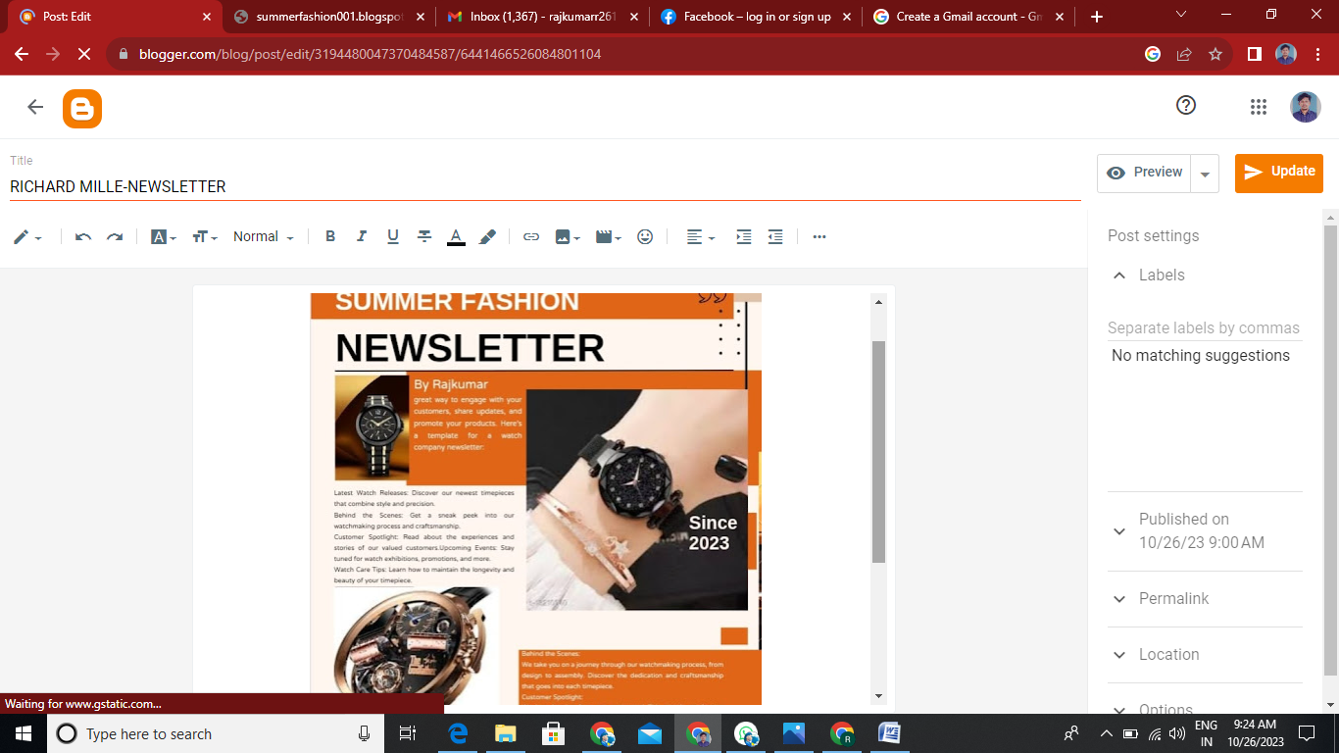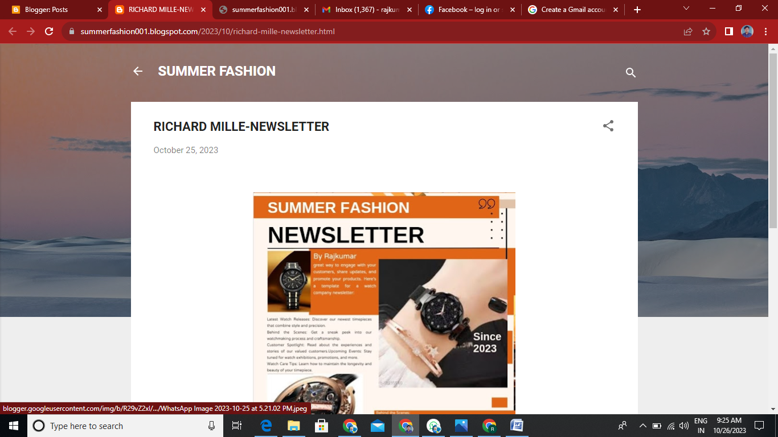

1. Create a New Facebook Business Page and post one social media poster for your brand.

Link: <https://www.facebook.com/profile.php?id=61552684054336>

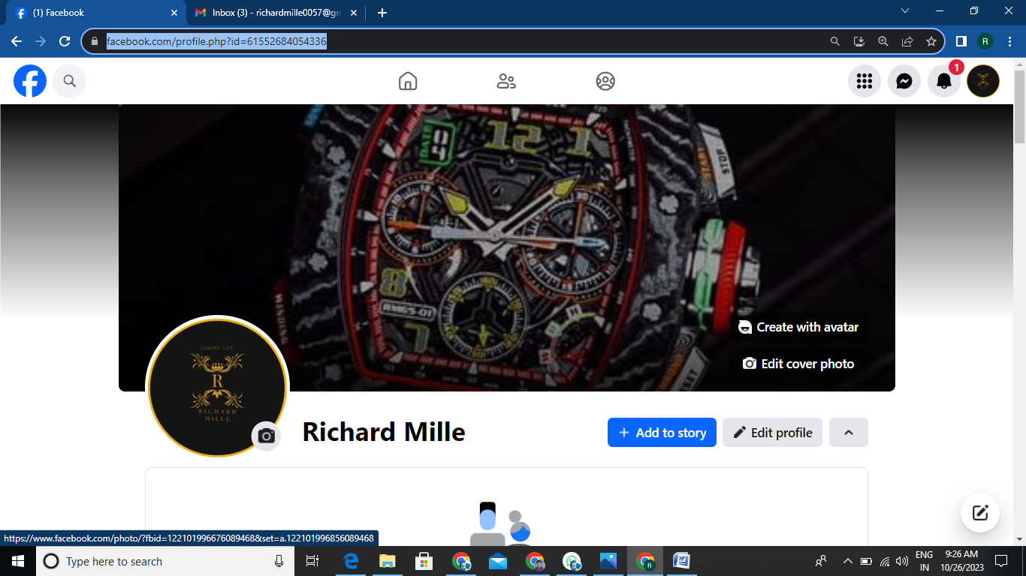

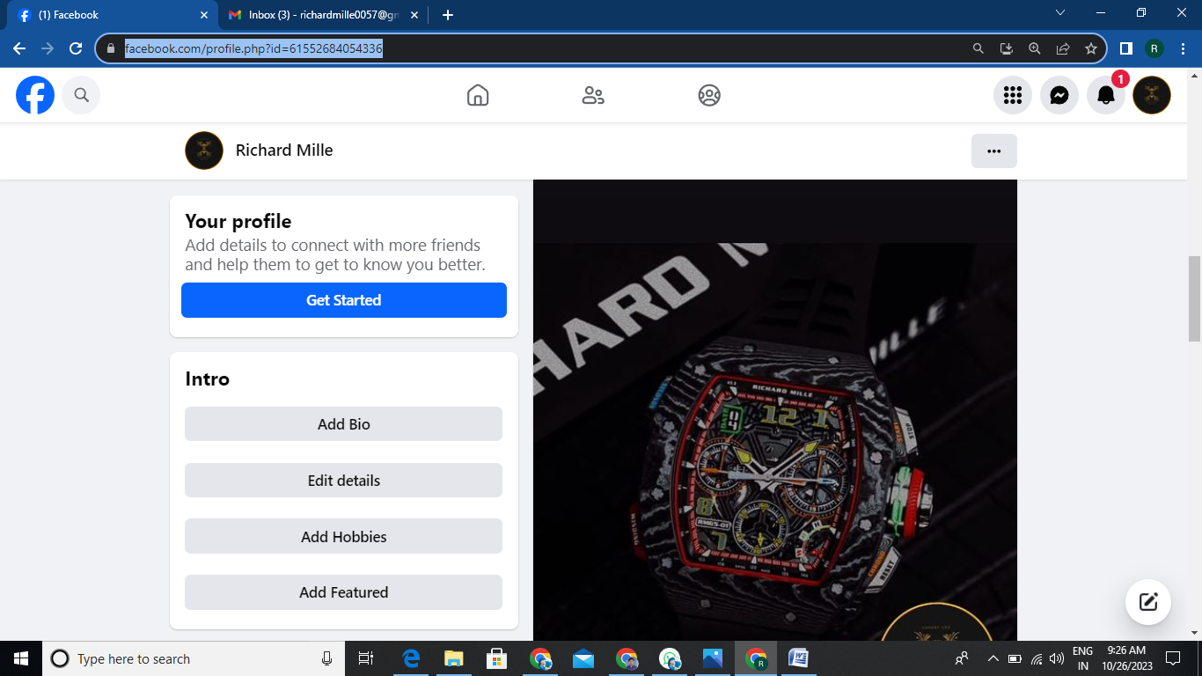

3.Create and design a social media advertisement poster using canva.

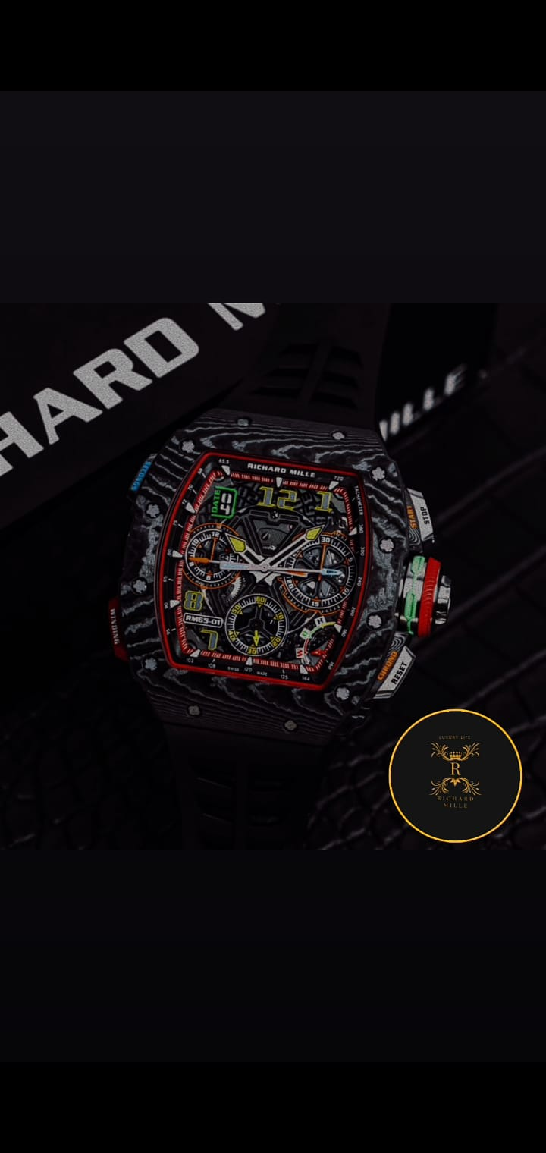

1. Create email newsletter design using MailChimp or canva tool.

Link: <https://summerfashion001.blogspot.com/2023/10/richard-mille-newsletter.html>

